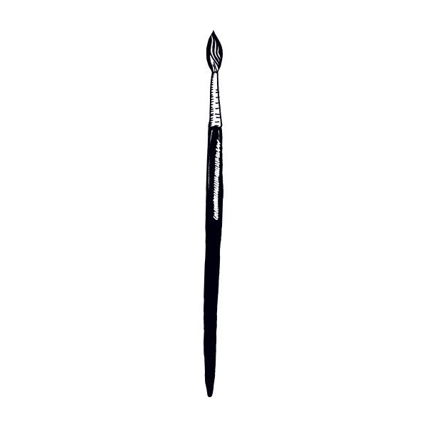

**Grading**

Every student is an artist in their own way, and grades are not based on artistic ability. There are two main categories for grading:

1. Studio Habits: 75%

Students will receive a weekly grade based on their engagement, responsibility of materials, and a written reflection. This assessment is based on the 8 Studio Habits of Mind. (Hetland L., Winner, E., Veenam S., Sheridan, K. (2013) Studio Thinking 2: The Real Benefits of a Visual Arts Education, NY: Teachers College Press).

2. WOW Artworks: 25%

Students will be required to create at least 3 “Wonderful Original Works of Art” due periodically throughout the 9 weeks. Rubrics will be given ahead of time.

**Materials Needed Daily:**

Pencil  Portfolio  Sketchbook  Device for research if available  Growth mindset.

*Please bring a poster board (22”x28”) to make your portfolio.

**___________________________**

**Student Expectations in the**

**Art Room:**

**1. Take Care of People**

**2. Take Care of Materials**

**3. Behave like an Artist**

**_____________________________**

**A little something about**

**your teacher:**

Mrs. Collier grew up in Brighton, TN and received her Art Education degree from MTSU and her Master’s in Education from MTSU as well. She currently lives in Murfreesboro with her husband (John) and cat (Montague).

**In this class students will…**

- Generate & conceptualize artistic ideas and work.

- Organize & develop artistic ideas & work.

-Refine & complete artistic work.

- Analyze, interpret, & select artwork for presentation.

- Develop & refine artwork for presentation.

- Convey meaning through the presentation of artwork.

- Perceive & analyze artworks.

- Interpret intent & meaning in artworks.

- Apply criteria to evaluate artworks

- Synthesize & relate personal knowledge & experiences to make art.

- Relate artistic ideas & works with societal, cultural, & historical context to deepen understanding.

*National Core Art Anchor Standards*

This 9-weeks is filled with activities and projects that will boost your critical thinking skills, improve your collaboration, and grow your creativity through discussions, writing, and creating. Due in part to new Visual Arts Standards, I am adopting the “TAB” (Teaching for Artistic Behavior) approach to art education. TAB focuses on student choice and recognizes students as artists. It is more about the process or thinking behind making a work of art rather than the product. Ultimately, it encourages authentic learning as students experiment with materials of their choice while they seek to represent their own ideas and connect with the world around them. Please check my webpage on the school website for class worksheets, rubrics, resources, and updates.

Please check my webpage on the school website for class worksheets, rubrics, resources, and updat

+ + + + + + + + + + + + + + + + + + + + + + + + + + + + + + + + + + + + + + + + + + + + + + + + + + + + + + + + + + + + + + + + + +

Student Name: ______________________________ Student Class Period: __________________

Parent Name: _______________________________ Parent Contact (Number or Email): __________________

If your student has any health concerns I should be aware of, please list them here or on the back:

Mrs. Samantha Collier

Room #501

Colliers@rcschools.net

Twitter: bms_art_room

{2017-2018 Syllabus}

Welcome to

Blackman Middle School

ART