Name: ___________________________________________ Class: _____________________ Date: _____________________________
My W.O.W. Artwork
MY IDEA: Sketch in this box.  1 | 2  MY PLAN:  What studio centers will you need to use? (Circle all that apply)  Drawing Sculpture Fiber Arts  Painting Clay Digital Media  Collage Printmaking  _________________________________________________________  Materials: (List everything you think you will need.)

Subject and Meaning:
3

Composition: (circle all that apply)
4
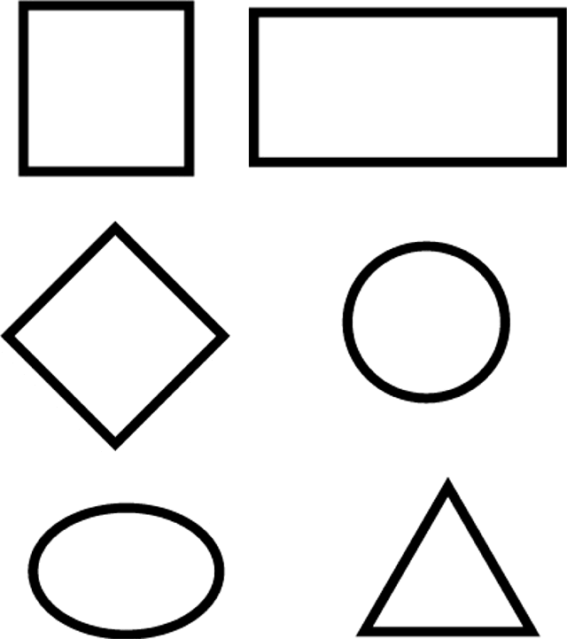

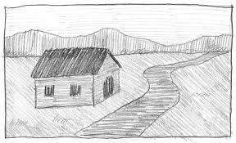
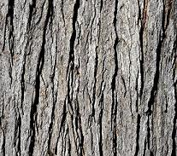
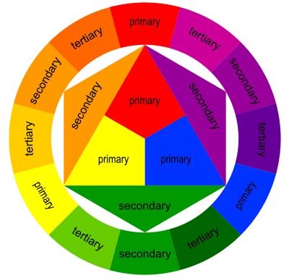
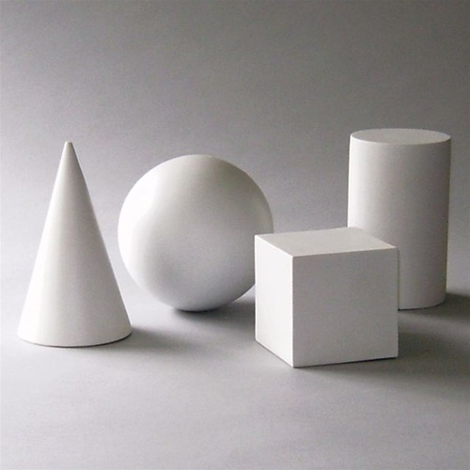
Line Color Shape Value Texture Form Space

Something I want people to notice in my finished artwork:
5

Teacher Initials: ___________________

